1. INTRODUCTION
   1. Overview

The ‘crafting visually striking certificates for a debate

Competition using canva ‘’project focuses on creating

Impressive and memorable certificates to recognize

The participants

* 1. purpose

To participants ,winners ,and contributors of a debate

Competition . crafting visually appealing using canva.

1. problem Definition &Designing Thinking
   1. Empathy Map

Paste the empathy map screenshot

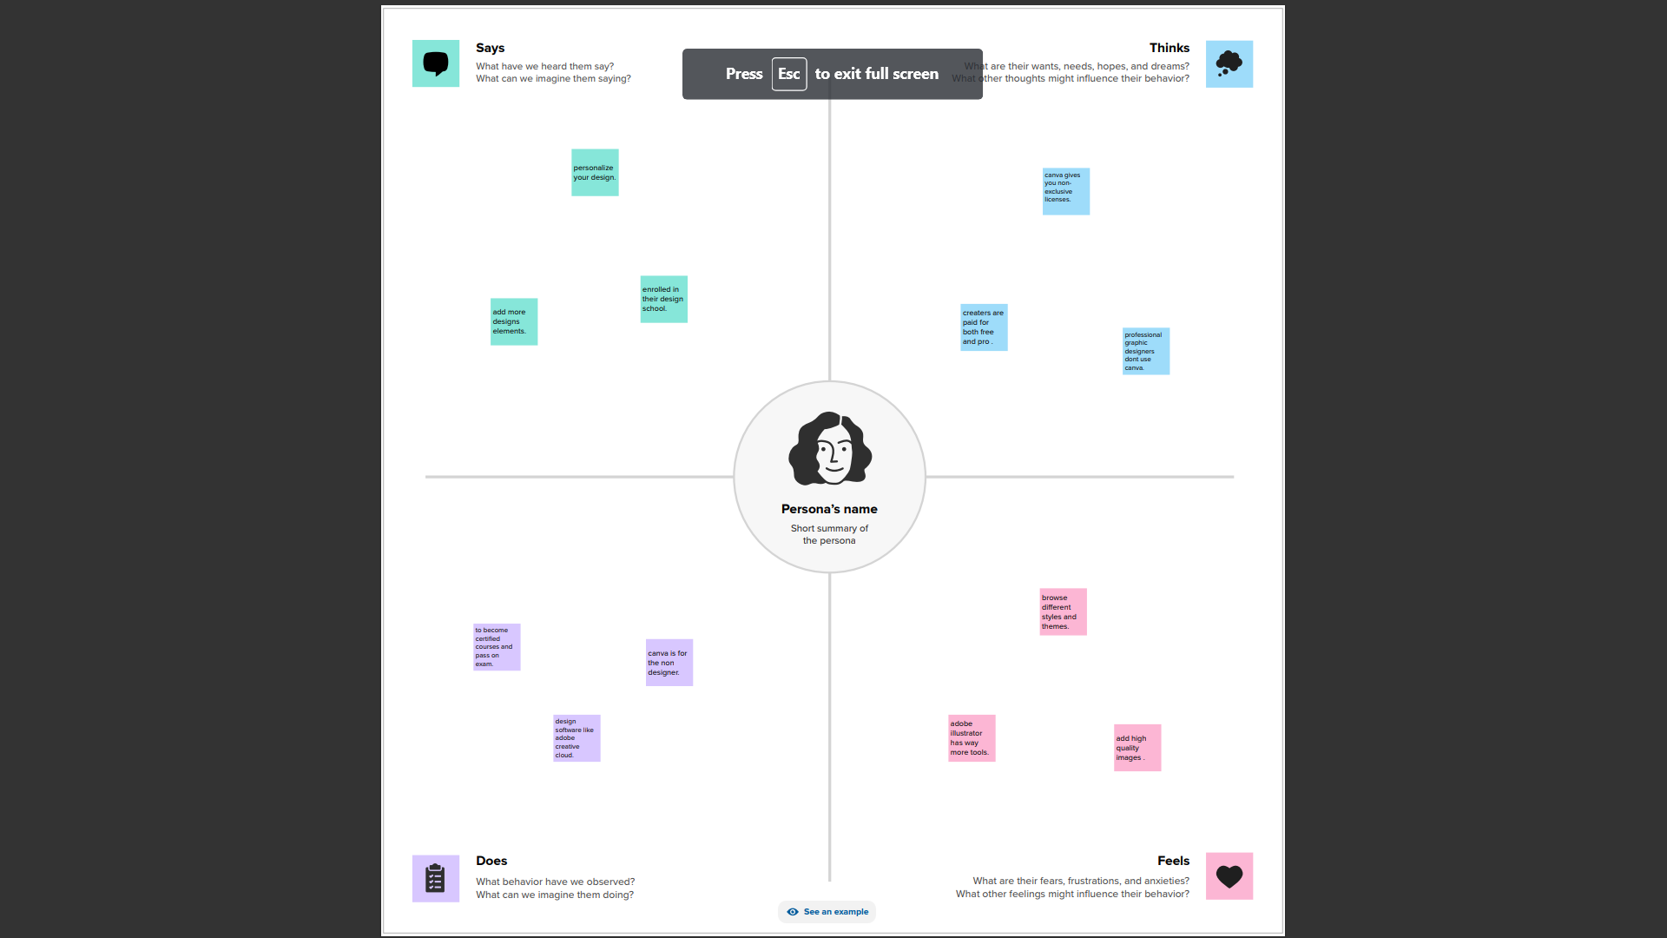

* 1. Ideation &Brainstorming map screenshot

Paste the ideation &brainstorming map screenshot

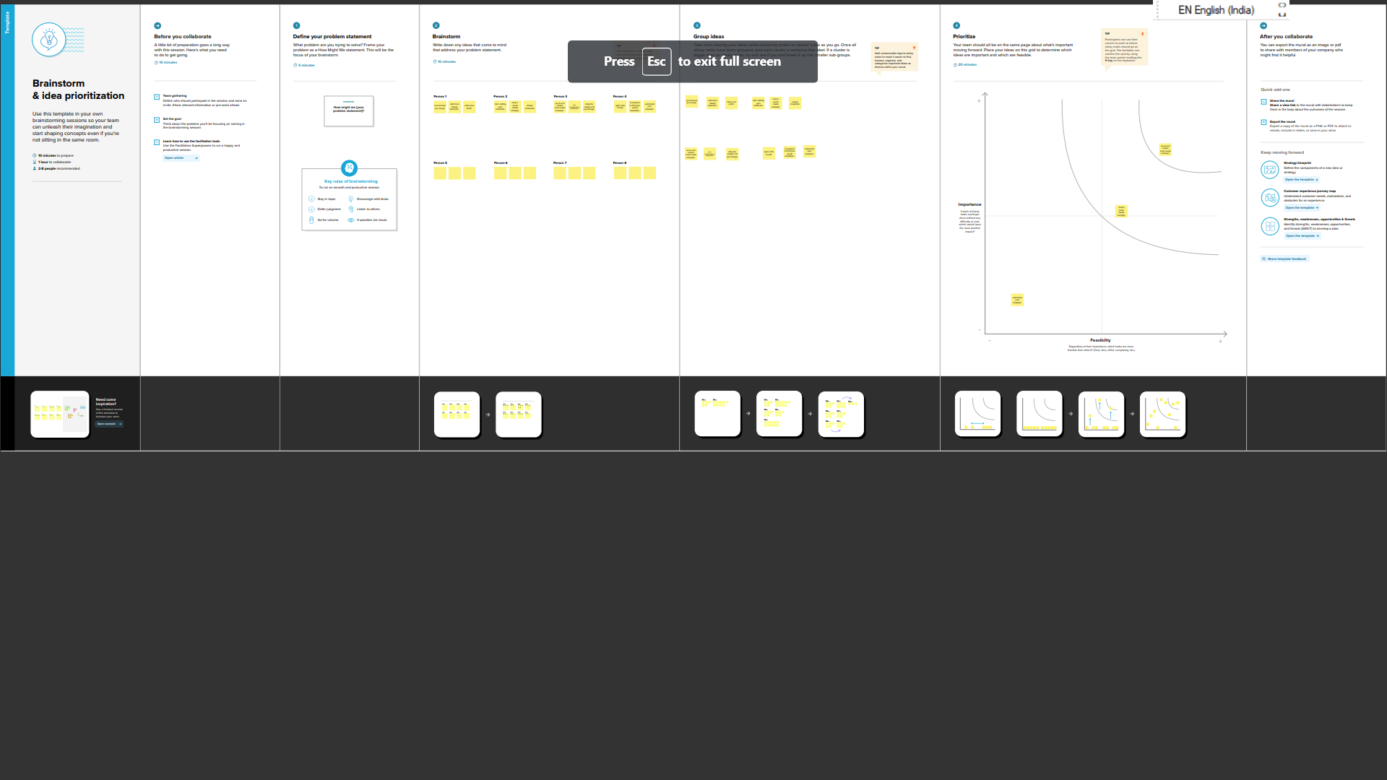

1. RESULT

Final flindings (output)of the project along with screenshot

